**ÇANKAYA UNIVERSITY**

**FACULTY OF ENGINEERING**

**COMPUTER ENGINEERING DEPARMENT**

**CENG 407**

**LITERATURE  
REVIEW**

**SERENAY GÜNEŞ**

**201111024**

**AYÇANUR NİLÜFER ODAMAN**

**201111037**

**ÇAĞRI GENÇER**

**201411208**

**ADVISOR  
MURAT SARAN**

Contents

1. Articles 3

References 11

List of Figures

Figure 1: Typical architecture of an OMR processing system 4

Figure 2: Stages of the OMR system 5

Figure 3: The original note page 6

Figure 4: Staff lines removed in Original Note Page (Figure 3) 7

Figure 5: System high level design 8

Figure 6: Playscore Lite 9

Abstract

In this literature review, we will present previous research studies and applications related with our project which is about music notes archive system integrated with optical music recognition. Optical Music Recognition (OMR) is a software system which can be used to transmit musical notes into an editable symbolic format digitally. In this literature review, firstly we explain what is Optical Music Recognition (OMR) and introduce the steps of Optical Music Recognition. According to the literature, these steps include mainly staff line identification, musical object location, musical feature classification, and musical semantics. Moreover, the general framework to be used in our study is presented. The success factors for an Optical Music Recognition (OMR) systems are employing effective image processing algorithms and getting satisfactory results for composers and musicians with an understandable and easy to use user interface.

**Öz**

Bu literatür araştırmasında, Optik Müzik Tanımlama hakkında yazılan makaleler, yapılan araştırmalar ve Optik Müzik Tanımlama da kullanılan algoritmaları temel alan Android ve IOS uygulamaları sunulmuştur. Optik Müzik Tanımlama uygulamalarında müzik notalarını içeren basılı sayfalar görüntü işleme teknikleri kullanılarak dijital ortama aktarılmaktadır. Bu literatür araştırmasında genel olarak Optik Müzik Tanımlama süreçlerini ve problemlerini inceledik. Bu süreçlerde öncelikle müzik çizgilerini tanınması ve daha sonra ise ilgili çizgiye denk gelen notayı tanıyıp isimlendirmenin nasıl yapılabileceği sunulmuştur.

1. Optical Music Recognition

Bainbridge and Bell [1] argues that Optical Music Recognition (OMR) is associated with Optical Character Recognition (OCR) system. However, OMR systems have some important extra complexities. According to Bainbridge and Bell, Optical Music Recognition have the following four steps in their recognition process. These processes are (i) stave line identification, (ii) musical object location, (iii) symbol identification, and (iv) semantics of music notation.

Rebelo et al. [2] state OMR systems include objects, recognition, representation, and storage of musical notes in digital format. They mention OMR architecture and typical framework in their study. This framework includes four main points, these are image processing, recognition of musical symbols, reconstruction of the musical information in order to build a logical description of musical notation; and construction of a musical notation model to be represented as a symbolic description of the musical sheet. Figure 1 shows typical architecture of an OMR processing system presented by Rebelo et al.

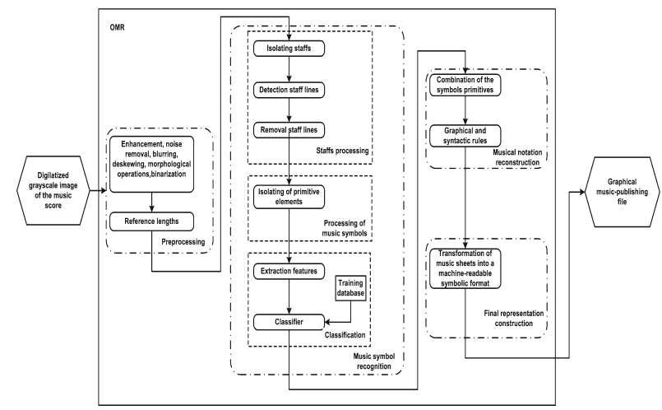

Figure 1: Typical architecture of an OMR processing system

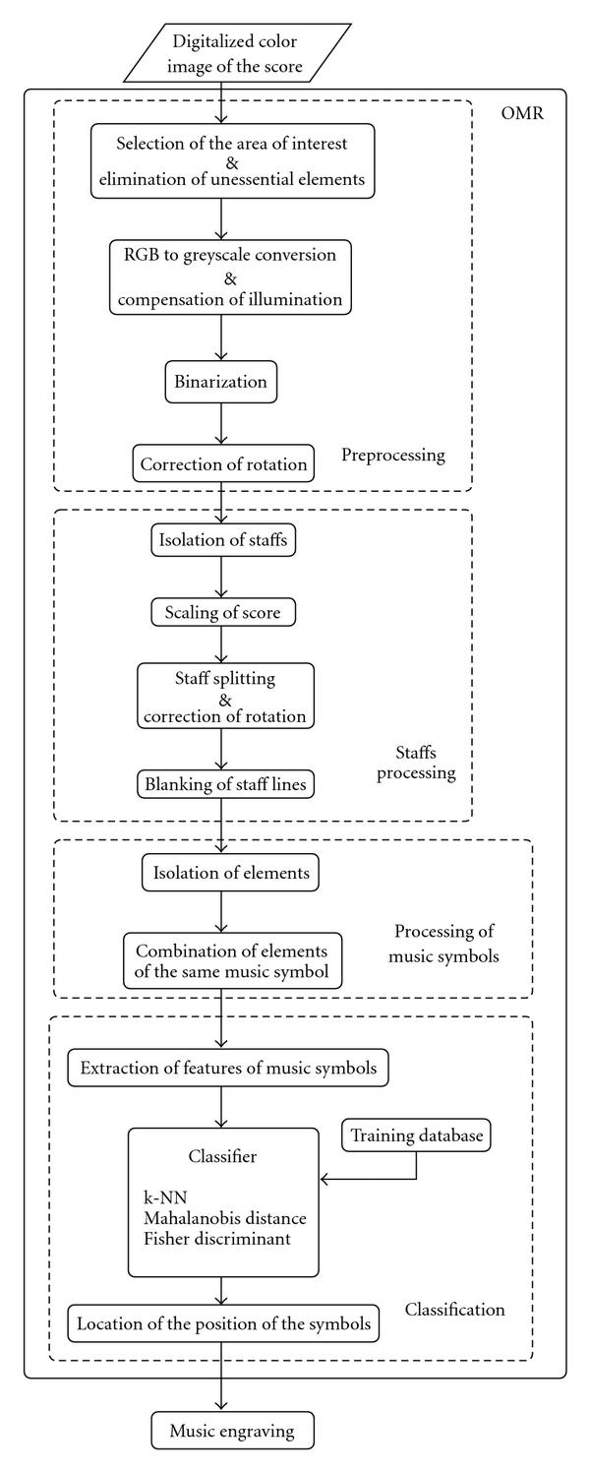Tardón et al. [3] propose an OMR (Optical Music Recognition) system that includes similar stages aforementioned studies. These steps are image pre-processing stage, process of detection and blanking the staff lines, extract complex music symbols, classification of the music symbols. Figure 2 displays these stages.

Figure 2: Stages of the OMR system

The image pre-processing step in OMR system includes the following steps: (i) selection of the area of interest and elimination of non-musical elements, (ii) grayscale conversion and illumination compensation, (iii) image binarization, and (iv) correction of image rotation. The staff processing procedure performs to detect and remove the staff lines. According to Tardón et al., processing of music symbols includes two main steps. These are isolation of music elements and combination of elements. These two steps belong to the same music symbol. The final stage is classification. This procedure performs to compare unknown symbols and known symbols. After comparing, the procedure identifies and locates these symbols.

Fujinaga [4] studies on AOMR (Adaptive Optical Music Recognition) project to create a powerful framework within which a practical optical music recognition (OMR) system can be built. The AOMR system includes creation of a database and three processes: recognizer, editor, and learner. AOMR software contains seven main stages. These are (i) staff detection and removal, (ii) text removal, (iii) segmentation, (iv) feature extraction, (v) classification, (vi) score reconstruction, and (vii) learning phase. An example of original note page is presented in Figure 3 and Figure 4 displays the note page without staff line removed by the AOMR system.

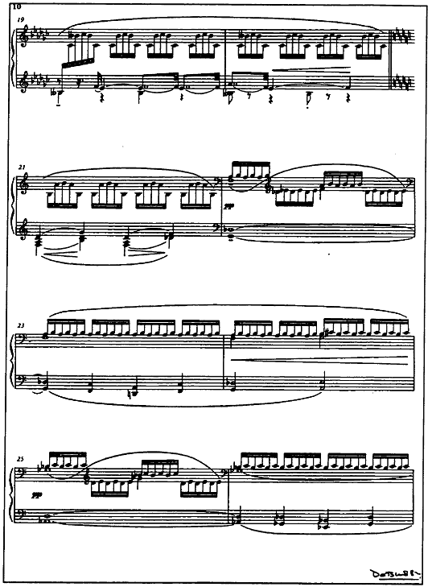

Figure 3: The original note page

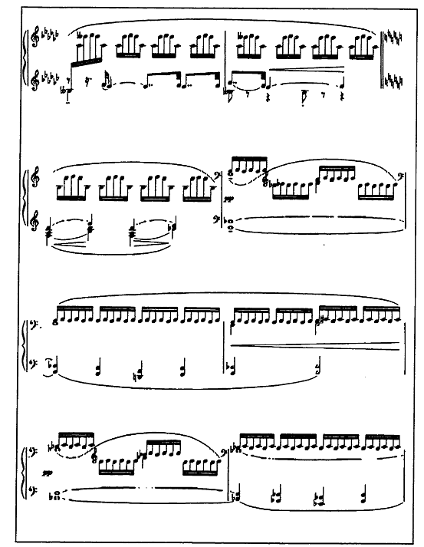

Figure 4: Staff lines removed in Original Note Page (Figure 3)

Ben-Dayan and Giloh [5] study on a project with Optical Music Recognition which is live camera recognition of handwritten musical notes. In this project, they claim to create a robust system that can deal with multiple users. They study to make powerful detection and recognition process that is independent from video camera process. They apply the processes in the following order as shown in Figure 5: (i) video frames capture, (ii) image pre-processing, (iii) staff detection and separation, (iv) staff lines detection and removal, (v) stems/beams detection and separation, (vi) note head and features detection, (vii) note duration feature detection, (viii) non-note symbols detection, (ix) musical properties decision, (x) music playback.

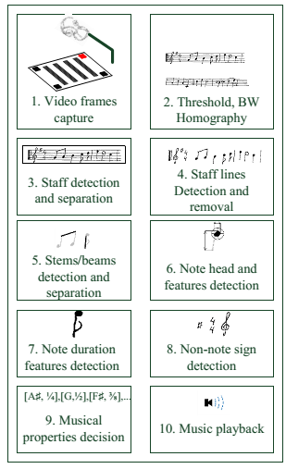

Figure 5: System high level design

In his study, W. Pedrycz [6] tries to find answers of the problems related with music notes recognition. The first problem is how to recognize specific musical notes. The second problem is finding which notes are presented and played or what value does musical notes have. Especially, he focuses on scanning phase. Scanning units include staff lines, beams etc. Process of recognition staff lines system finds where five lines are located into the piece of a sheet. Because of noise and quantization it is not simple task. He studies mainly on staff line removal since in order to avoid their negative influence on music notes recognition.

Barahona and Alfere [7] write about image pre-processing and recognition. They store scanned sheet of music in a TIFF file. TIFF file provides a sheet of music filtered from some kinds of noises. Their method copes with curvature of staff lines. After detecting staff lines, they are removed from the image to isolate musical notes. However, this system does not work perfectly because of distinguishing staff lines from object.

Tanguiane [8] mentions about artificial perception to music recognition and developing computer system which is about automatic notation of performed music. Mostly, chord spectra and ambiguity in rhythm perception are explained.

López [9] talks about image processing and artificial intelligence techniques to the automatic recognition of music elements from handwriting document images. It is similarly optical character recognition system and graphic recognition system. Moreover, NIFF (Notation Interchange File Format) and MIDI (Music International Device Interface) which are musical description files are searched to product musical description. He explains the musical scores five parts. These parts are formed image pixels, finding graphical primitives (dotes, lines, circles, and curves), finding musical symbols, layer of semantic (meaning) layer (pitch and beats) and grammar rules. Detecting vertical lines are tested with Hough Transform and a line tracking algorithm.

Playscore Lite [10] is similar with our project subject. People can snap or load a page of printed music and follow it on screen as the music plays. Using the latest techniques in optical music recognition plays music as it should sound, naturally and smoothly. People can also follow the music on screen as it plays. Figure 6 shows the screenshot of the Playscore Lite application available on both App Store and Google Play.

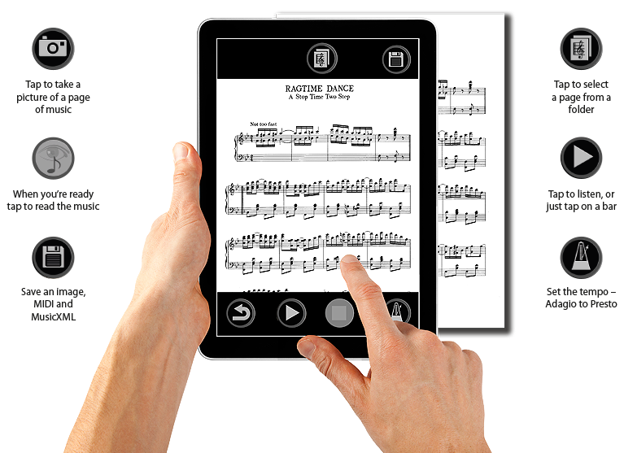

Figure 6: Playscore Lite

SnapNPlay Music [11] is another important application that allows playing music from picture of sheet. First you take a photo of printed sheet music and then select an option between piano, recorder, guitar, violin, viola, cello and bass. After uploading process you can learn, watch and follow positions of musical notes.

Read Sheet Music [12] is designed to recognize musical notes values and read musical notes. Animations help to follow musical notes.

References

|  |  |
| --- | --- |
| [1] | B. Bell, “waikato,” [Online]. Available: http://www.cs.waikato.ac.nz/~davidb/publications/acsc96/. [Accessed 5 November 2015]. |
| [2] | Rebelo, “Springer,” [Online]. Available: http://download.springer.com/static/pdf/527/art%253A10.1007%252Fs13735-012-0004-6.pdf?originUrl=http%3A%2F%2Flink.springer.com%2Farticle%2F10.1007%2Fs13735-012-0004-6&token2=exp=1446840650~acl=%2Fstatic%2Fpdf%2F527%2Fart%25253A10.1007%25252Fs13735-012-000. [Accessed 5 November 2015]. |
| [3] | Tardon, “eurasipjournals,” [Online]. Available: http://www.jivp.eurasipjournals.com/content/2009/1/843401#sec8. [Accessed 5 November 2015]. |
| [4] | Fujinaga. [Online]. Available: http://www.nlc-bnc.ca/obj/s4/f2/dsk2/ftp02/NQ29937.pdf. [Accessed 6 November 2015]. |
| [5] | G. Ben Dayan. [Online]. Available: http://www.ee.bgu.ac.il/~iip/Projects/Projects_2013/Project_num_8/Reports/PROJECT_8_FINAL_REPORT2012.pdf. [Accessed 6 November 2015]. |
| [6] | W. Pedrycz, in *Granular Computing: An Emerging Paradigm*, Poland, Springer Verlag, 2001, pp. 348-349. |
| [7] | P. Barahona and J. J. Alferes, in *Progress in Artificial Intelligence* , Portugal, Series, 1999 , p. 348. |
| [8] | A. S. Tanguiane, in *Artificial Perception and Music Recognition*, Springer-Verlag, 1993. |
| [9] | B. López, in *Artificial Intelligence Research and Development*, IOS Press, 2005, p. 85. |
| [10] | “Playscore,” [Online]. Available: http://www.playscore.com/. [Accessed 7 November 2015]. |
| [11] | “SnapNPlay,” [Online]. Available: http://musical-snapnplay.com/. [Accessed 7 November 2015]. |
| [12] | “Read Sheet Music,” [Online]. Available: http://www.musycom.com/ia5_musycom/?idE=3045&idZ=3045. [Accessed 7 November 2015]. |